Task 3 (Search task):
How to track a character in a single string?
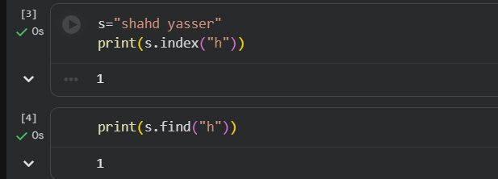
string.find('char') returns the index of the first occurrence.
string.index('char') is similar but raises a ValueError if the character is missing.
If we want to detect the second occurrence:
